**Instruction to Update Deque CCA Tool**

**Tool URL:** [**https://subbu7788.github.io/Dequecca/**](https://subbu7788.github.io/Dequecca/)

1. **Open the Deque CCA tool**
2. **Click on setting**

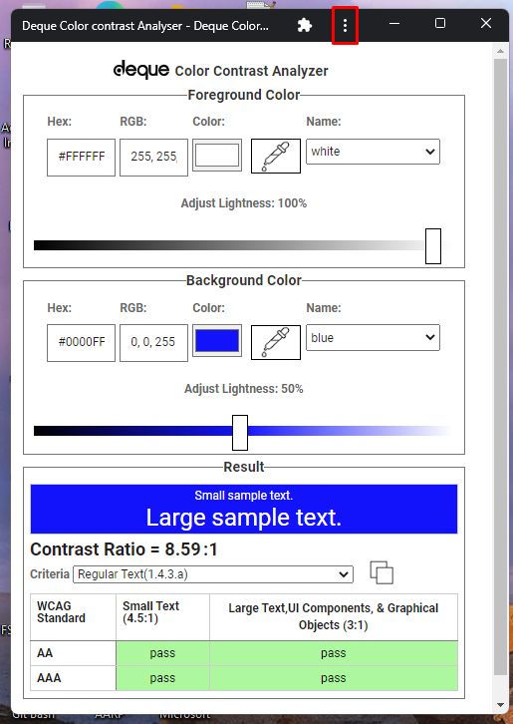

1. **Click on App info**

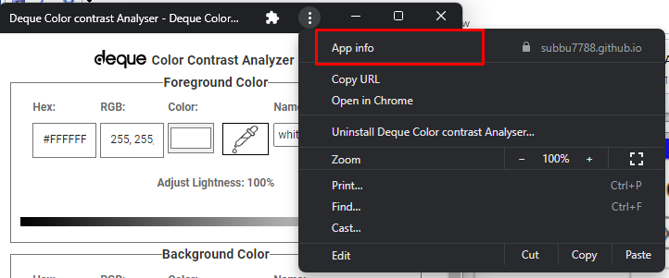

1. **Click on settings**

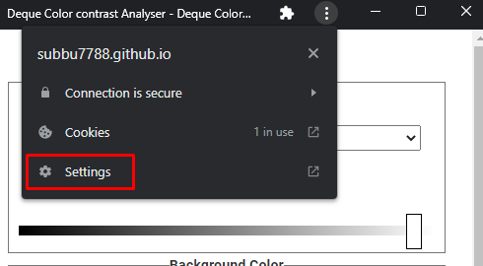

1. **Settings are displayed on the chrome browser. Click on the “More setting and Permissions”**

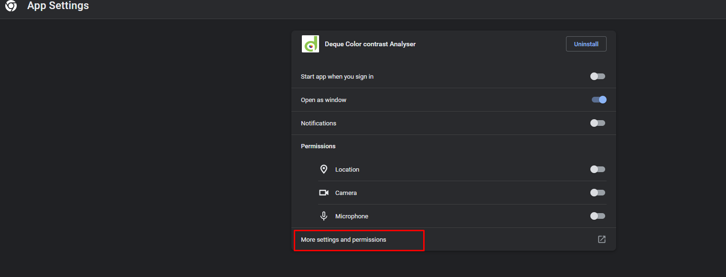

1. **Click on “Clear data”**

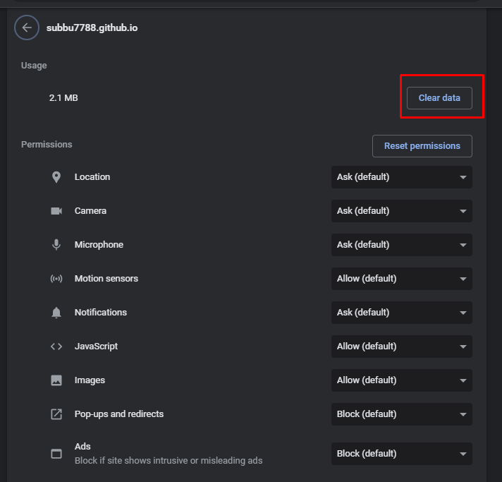

1. **Close the tool and relaunch to get the updated code**